# HybridMwStructure_Pac

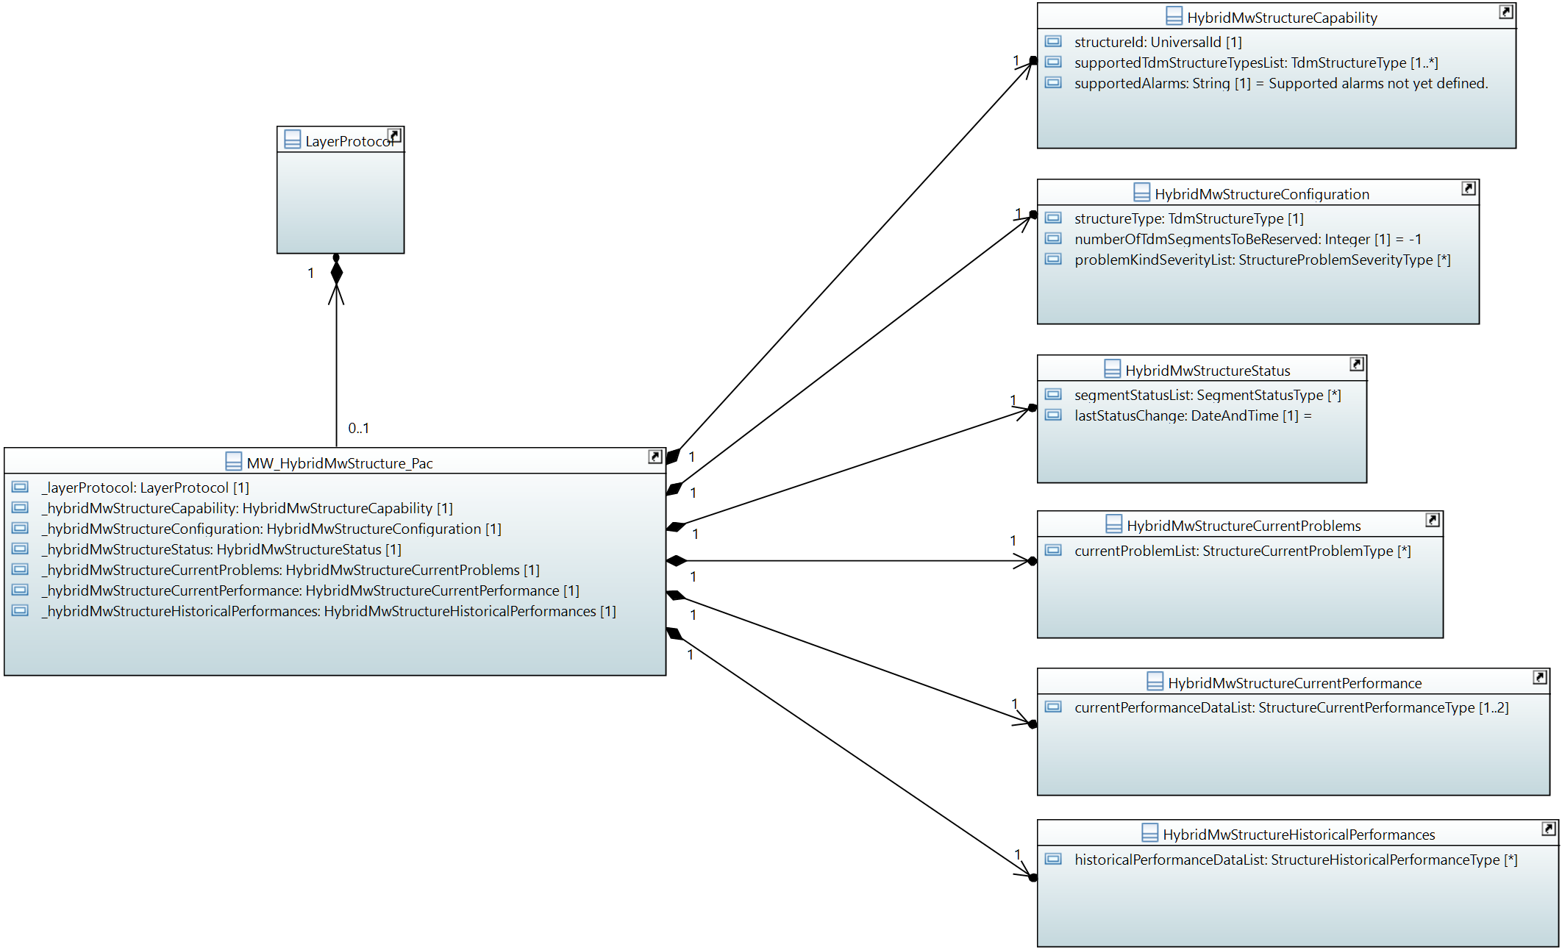

## MW_HybridMwStructure_Pac

Qualified Name: MicrowaveModel::ObjectClasses::HybridMwStructure::MW_HybridMwStructure_Pac

The HybridMwStructure_Pac and its attached classes MUST be provided on management interfaces of microwave devices, which are transporting TDM and Ethernet traffic.

Applied stereotypes:

* OpenModelClass
* objectCreationNotification: YES
* objectDeletionNotification: YES
* support: CONDITIONAL_MANDATORY
* condition: Feature 'hybrid-microwave' is mandatory for device types transporting Ethernet + TDM.

Table 17: Attributes for MW_HybridMwStructure_Pac

| **Attribute Name** | **Type DefaultValue** | **Multiplicity** | **Access** | **Stereotypes** | **Description** |
| --- | --- | --- | --- | --- | --- |
| _layerProtocol | LayerProtocol  ./. | 1 | RW | OpenModelAttribute   * partOfObjectKey: 1 * AVC: NO * isInvariant: false * valueRange: no range constraint * bitLength: NA * unit: no unit defined * support: MANDATORY | CoreModel-CoreNetworkModule-ObjectClasses:NetworkElement/_ltpRefList/_lpList/uuid |
| _hybridMwStructureCapability | HybridMwStructureCapability  ./. | 1 | R | OpenModelAttribute   * partOfObjectKey: 0 * AVC: NO * isInvariant: false * valueRange: no range constraint * bitLength: NA * unit: no unit defined * support: MANDATORY | See referenced class |
| _hybridMwStructureConfiguration | HybridMwStructureConfiguration  ./. | 1 | RW | OpenModelAttribute   * partOfObjectKey: 0 * AVC: NO * isInvariant: false * valueRange: no range constraint * bitLength: NA * unit: no unit defined * support: MANDATORY | See referenced class |
| _hybridMwStructureStatus | HybridMwStructureStatus  ./. | 1 | R | OpenModelAttribute   * partOfObjectKey: 0 * AVC: NO * isInvariant: false * valueRange: no range constraint * bitLength: NA * unit: no unit defined * support: MANDATORY | See referenced class |
| _hybridMwStructureCurrentProblems | HybridMwStructureCurrentProblems  ./. | 1 | R | OpenModelAttribute   * partOfObjectKey: 0 * AVC: NO * isInvariant: false * valueRange: no range constraint * bitLength: NA * unit: no unit defined * support: MANDATORY | See referenced class |
| _hybridMwStructureCurrentPerformance | HybridMwStructureCurrentPerformance  ./. | 1 | R | OpenModelAttribute   * partOfObjectKey: 0 * AVC: NO * isInvariant: false * valueRange: no range constraint * bitLength: NA * unit: no unit defined * support: MANDATORY | See referenced class |
| _hybridMwStructureHistoricalPerformances | HybridMwStructureHistoricalPerformances  ./. | 1 | R | OpenModelAttribute   * partOfObjectKey: 0 * AVC: NO * isInvariant: false * valueRange: no range constraint * bitLength: NA * unit: no unit defined * support: MANDATORY | See referenced class |

## HybridMwStructureCapability

Qualified Name: MicrowaveModel::ObjectClasses::HybridMwStructure::HybridMwStructureCapability

Describes the logical structuring of the physical capacity provided by a hybrid microwave device (TDM + Ethernet). Segmentation is available. TDM transport is available.

Applied stereotypes:

* OpenModelClass
* objectCreationNotification: NO
* objectDeletionNotification: NO
* support: MANDATORY

Table 18: Attributes for HybridMwStructureCapability

| **Attribute Name** | **Type DefaultValue** | **Multiplicity** | **Access** | **Stereotypes** | **Description** |
| --- | --- | --- | --- | --- | --- |
| structureId | UniversalId  ./. | 1 | R | OpenModelAttribute   * partOfObjectKey: 1 * AVC: NO * isInvariant: true * valueRange: no range constraint * bitLength: NA * unit: no unit defined * support: MANDATORY | Identifies the Structure for bundling and container. |
| supportedTdmStructureTypesList | TdmStructureType  ./. | 1..* | R | OpenModelAttribute   * partOfObjectKey: 0 * AVC: NO * isInvariant: true * valueRange: no range constraint * bitLength: NA * unit: no unit defined * support: MANDATORY | Lists the TDM frame types that are supported. |
| supportedAlarms | String  Supported alarms not yet defined. | 1 | R | OpenModelAttribute   * partOfObjectKey: 0 * AVC: NO * isInvariant: true * valueRange: no range constraint * bitLength: NA * unit: no unit defined * support: MANDATORY | Available alarms to be listed. Mandatory:non. Names are to be separated by commas. Further alarms might be added by the device. |

## HybridMwStructureConfiguration

Qualified Name: MicrowaveModel::ObjectClasses::HybridMwStructure::HybridMwStructureConfiguration

Applied stereotypes:

* OpenModelClass
* objectCreationNotification: NO
* objectDeletionNotification: NO
* support: MANDATORY

Table 19: Attributes for HybridMwStructureConfiguration

| **Attribute Name** | **Type DefaultValue** | **Multiplicity** | **Access** | **Stereotypes** | **Description** |
| --- | --- | --- | --- | --- | --- |
| structureType | TdmStructureType  ./. | 1 | RW | OpenModelAttribute   * partOfObjectKey: 0 * AVC: YES * isInvariant: false * valueRange: no range constraint * bitLength: NA * unit: no unit defined * support: MANDATORY | TDM frame to be applied. |
| numberOfTdmSegmentsToBeReserved | Integer  -1 | 1 | RW | OpenModelAttribute   * partOfObjectKey: 0 * AVC: YES * isInvariant: false * valueRange: no range constraint * bitLength: LENGTH_16_BIT * unit: no unit defined * support: MANDATORY | Allows to configure the number of segments reserved for TDM frames of the type specified in HybridMwStructure::HybridMwStructureConfiguration::structureType |
| problemKindSeverityList | StructureProblemSeverityType  ./. | 0..* | RW | OpenModelAttribute   * partOfObjectKey: 0 * AVC: YES * isInvariant: false * valueRange: no range constraint * bitLength: NA * unit: no unit defined * support: MANDATORY | Severity of the type of problem to be configured. |

## HybridMwStructureStatus

Qualified Name: MicrowaveModel::ObjectClasses::HybridMwStructure::HybridMwStructureStatus

Applied stereotypes:

* OpenModelClass
* objectCreationNotification: NO
* objectDeletionNotification: NO
* support: MANDATORY

Table 20: Attributes for HybridMwStructureStatus

| **Attribute Name** | **Type DefaultValue** | **Multiplicity** | **Access** | **Stereotypes** | **Description** |
| --- | --- | --- | --- | --- | --- |
| segmentStatusList | SegmentStatusType  ./. | 0..* | R | OpenModelAttribute   * partOfObjectKey: 0 * AVC: YES * isInvariant: false * valueRange: no range constraint * bitLength: NA * unit: no unit defined * support: MANDATORY | Status of each segment (all TDM and one Ethernet). Multiplicity = HybridMwStructure::StructureConfiguration::tdmReservedNumberOfSegments + 1 |
| lastStatusChange | DateAndTime  20101120140000.0Z+1 | 1 | R | OpenModelAttribute   * partOfObjectKey: 0 * AVC: NO * isInvariant: false * valueRange: no range constraint * bitLength: NA * unit: no unit defined * support: MANDATORY | Time and date of the last update of the status information. _format:yyyyMMddhhmmss.s[Z|{+|-}HHMm]; yyyy='0000'..'9999' year; MM='01'..'12' month; dd='01'..'31' day; hh='00'..'23' hour; mm='00'..'59' minute; ss='00'..'59' second; s='.0'..'.9'tenth of second (set to '.0' if EMS or NE cannot support this granularity); Z='Z' indicates UTC (rather than local time); {+|-}='+' or '-' delta from UTC; HH='00'..'23' time zone difference in hours; Mm='00'..'59' time zone difference in minutes. |

## HybridMwStructureCurrentProblems

Qualified Name: MicrowaveModel::ObjectClasses::HybridMwStructure::HybridMwStructureCurrentProblems

Applied stereotypes:

* OpenModelClass
* objectCreationNotification: NO
* objectDeletionNotification: NO
* support: MANDATORY

Table 21: Attributes for HybridMwStructureCurrentProblems

| **Attribute Name** | **Type DefaultValue** | **Multiplicity** | **Access** | **Stereotypes** | **Description** |
| --- | --- | --- | --- | --- | --- |
| currentProblemList | StructureCurrentProblemType  ./. | 0..* | R | OpenModelAttribute   * partOfObjectKey: 0 * AVC: NO * isInvariant: false * valueRange: no range constraint * bitLength: NA * unit: no unit defined * support: MANDATORY |  |

## HybridMwStructureCurrentPerformance

Qualified Name: MicrowaveModel::ObjectClasses::HybridMwStructure::HybridMwStructureCurrentPerformance

Aggregated performance information of the structure of a hybrid microwave at a particular moment.

Applied stereotypes:

* OpenModelClass
* objectCreationNotification: NO
* objectDeletionNotification: NO
* support: MANDATORY

Table 22: Attributes for HybridMwStructureCurrentPerformance

| **Attribute Name** | **Type DefaultValue** | **Multiplicity** | **Access** | **Stereotypes** | **Description** |
| --- | --- | --- | --- | --- | --- |
| currentPerformanceDataList | StructureCurrentPerformanceType  ./. | 1..2 | R | OpenModelAttribute   * partOfObjectKey: 0 * AVC: NO * isInvariant: false * valueRange: no range constraint * bitLength: NA * unit: no unit defined * support: MANDATORY | At least values of the counters, which are reset every 15 minutes, are to be provided. If available, the current values of the counters, which are reset every 24 hour, can be provided, too. |

## HybridMwStructureHistoricalPerformances

Qualified Name: MicrowaveModel::ObjectClasses::HybridMwStructure::HybridMwStructureHistoricalPerformances

Aggregated performance information of the structure of a hybrid microwave for a pre-defined measurement interval.

Applied stereotypes:

* OpenModelClass
* objectCreationNotification: NO
* objectDeletionNotification: NO
* support: MANDATORY

Table 23: Attributes for HybridMwStructureHistoricalPerformances

| **Attribute Name** | **Type DefaultValue** | **Multiplicity** | **Access** | **Stereotypes** | **Description** |
| --- | --- | --- | --- | --- | --- |
| historicalPerformanceDataList | StructureHistoricalPerformanceType  ./. | 0..* | R | OpenModelAttribute   * partOfObjectKey: 0 * AVC: NO * isInvariant: false * valueRange: no range constraint * bitLength: NA * unit: no unit defined * support: MANDATORY |  |

# Data Types

## TdmStructureType

Qualified Name: MicrowaveModel::TypeDefinitions::TdmStructureType

Table 60: Attributes for TdmStructureType

| **Attribute Name** | **Type DefaultValue** | **Multiplicity** | **Access** | **Stereotypes** | **Description** |
| --- | --- | --- | --- | --- | --- |
| tdmStructureName | String  TDM structure name not defined. | 1 | R | OpenModelAttribute   * partOfObjectKey: 1 * AVC: NO * isInvariant: true * valueRange: no range constraint * bitLength: NA * unit: no unit defined * support: MANDATORY | Names to be chosen from the following list: 'e1','t1','j1','e3','ds3','stm1','cpri1','cpri2','cpri3','cpri4','cpri5','cpri6' or 'cpri7' |
| tdmSegmentSize | Integer  -1 | 1 | R | OpenModelAttribute   * partOfObjectKey: 0 * AVC: NO * isInvariant: true * valueRange: no range constraint * bitLength: LENGTH_32_BIT * unit: kbit/s * support: MANDATORY | Size of the TDM segment in kbit/s. Values to be chosen from the following list: '2048','1544','34000','44736 ','155520','614400','1228800','2457600','3072000','4915200','6144000' or '9830400; |
| maxNumberOfSegmentsReservable | Integer  -1 | 1 | R | OpenModelAttribute   * partOfObjectKey: 0 * AVC: NO * isInvariant: true * valueRange: no range constraint * bitLength: LENGTH_8_BIT * unit: segments * support: MANDATORY | Device specific maximum number of segments (not depending on current air interface configuration) that can be reserved for this type of segment on a single air interface. |

## StructureProblemSeverityType

Qualified Name: MicrowaveModel::TypeDefinitions::StructureProblemSeverityType

Table 61: Attributes for StructureProblemSeverityType

| **Attribute Name** | **Type DefaultValue** | **Multiplicity** | **Access** | **Stereotypes** | **Description** |
| --- | --- | --- | --- | --- | --- |
| problemKindName | String  Problem kind name not defined. | 1 | RW | OpenModelAttribute   * partOfObjectKey: 1 * AVC: NA * isInvariant: true * valueRange: no range constraint * bitLength: NA * unit: no unit defined * support: MANDATORY | Name of the alarm according to Structure::StructureCapability::supportedAlarms |
| problemKindSeverity | SeverityType  WARNING | 1 | RW | OpenModelAttribute   * partOfObjectKey: 0 * AVC: YES * isInvariant: false * valueRange: no range constraint * bitLength: NA * unit: no unit defined * support: MANDATORY | Severity of this type of alarm. |

## StructureCurrentProblemType

Qualified Name: MicrowaveModel::TypeDefinitions::StructureCurrentProblemType

Table 62: Attributes for StructureCurrentProblemType

| **Attribute Name** | **Type DefaultValue** | **Multiplicity** | **Access** | **Stereotypes** | **Description** |
| --- | --- | --- | --- | --- | --- |
| problemName | String  Problem name not specified. | 1 | R | OpenModelAttribute   * partOfObjectKey: 0 * AVC: NO * isInvariant: true * valueRange: no range constraint * bitLength: NA * unit: no unit defined * support: MANDATORY | Name of the alarm according to Structure::StructureCapability::supportedAlarms |

## StructurePerformanceType

Qualified Name: MicrowaveModel::TypeDefinitions::StructurePerformanceType

Consolidated performance information of the Structure.

Table 63: Attributes for StructurePerformanceType

| **Attribute Name** | **Type DefaultValue** | **Multiplicity** | **Access** | **Stereotypes** | **Description** |
| --- | --- | --- | --- | --- | --- |
| timePeriod | Integer  -1 | 1 | R | OpenModelAttribute   * partOfObjectKey: 0 * AVC: NO * isInvariant: true * valueRange: no range constraint * bitLength: LENGTH_32_BIT * unit: s * support: MANDATORY | Total length of the measurement period in seconds. |

## StructureCurrentPerformanceType

Qualified Name: MicrowaveModel::TypeDefinitions::StructureCurrentPerformanceType

Turns performance information into current performance information by inheriting from OTN_CurrentData.

Table 64: Attributes for StructureCurrentPerformanceType

| **Attribute Name** | **Type DefaultValue** | **Multiplicity** | **Access** | **Stereotypes** | **Description** |
| --- | --- | --- | --- | --- | --- |
| performanceData | StructurePerformanceType  ./. | 1 | R | OpenModelAttribute   * partOfObjectKey: 0 * AVC: NO * isInvariant: true * valueRange: no range constraint * bitLength: NA * unit: no unit defined * support: MANDATORY |  |

## StructureHistoricalPerformanceType

Qualified Name: MicrowaveModel::TypeDefinitions::StructureHistoricalPerformanceType

Turns performance information into historical performance information by inheriting from OTN_HistoryData.

Table 65: Attributes for StructureHistoricalPerformanceType

| **Attribute Name** | **Type DefaultValue** | **Multiplicity** | **Access** | **Stereotypes** | **Description** |
| --- | --- | --- | --- | --- | --- |
| performanceData | StructurePerformanceType  ./. | 1 | R | OpenModelAttribute   * partOfObjectKey: 0 * AVC: NO * isInvariant: true * valueRange: no range constraint * bitLength: NA * unit: no unit defined * support: MANDATORY |  |

# Super Classes

## MwCurrentProblem

Qualified Name: MicrowaveModel::ObjectClasses::SuperClasses::MwCurrentProblem

Applied stereotypes:

* OpenModelClass
* objectCreationNotification: NO
* objectDeletionNotification: NO
* support: MANDATORY

Table 74: Attributes for MwCurrentProblem

| **Attribute Name** | **Type DefaultValue** | **Multiplicity** | **Access** | **Stereotypes** | **Description** |
| --- | --- | --- | --- | --- | --- |
| sequenceNumber | Integer  ./. | 1 | R | OpenModelAttribute   * partOfObjectKey: 1 * AVC: NO * isInvariant: true * valueRange: no range constraint * bitLength: LENGTH_32_BIT * unit: no unit defined * support: MANDATORY | Unique sequence number of the current problem object. |
| timeStamp | DateAndTime  20101120140000.0Z+1 | 1 | R | OpenModelAttribute   * partOfObjectKey: 0 * AVC: NO * isInvariant: true * valueRange: no range constraint * bitLength: NA * unit: no unit defined * support: MANDATORY | Time and date of the problem. _format:yyyyMMddhhmmss.s[Z|{+|-}HHMm]; yyyy='0000'..'9999' year; MM='01'..'12' month; dd='01'..'31' day; hh='00'..'23' hour; mm='00'..'59' minute; ss='00'..'59' second; s='.0'..'.9'tenth of second (set to '.0' if EMS or NE cannot support this granularity); Z='Z' indicates UTC (rather than local time); {+|-}='+' or '-' delta from UTC; HH='00'..'23' time zone difference in hours; Mm='00'..'59' time zone difference in minutes. |
| problemSeverity | SeverityType  WARNING | 1 | R | OpenModelAttribute   * partOfObjectKey: 0 * AVC: NO * isInvariant: true * valueRange: no range constraint * bitLength: NA * unit: no unit defined * support: MANDATORY | Severity of the alarm. |

# Notifications

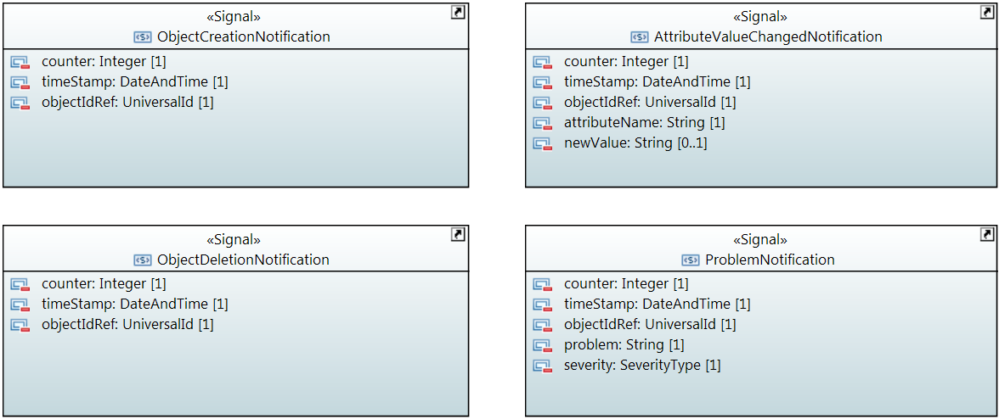

## AttributeValueChangedNotification

Qualified Name: MicrowaveModel::Notifications::AttributeValueChangedNotification

To be sent when an attribute has changed and one or more controllers have to update their data.

Applied stereotypes:

* OpenModelNotification
* triggerConditionList: invalid
* support: MANDATORY

Table 75: Attributes for AttributeValueChangedNotification

| **Attribute Name** | **Type DefaultValue** | **Multiplicity** | **Access** | **Stereotypes** | **Description** |
| --- | --- | --- | --- | --- | --- |
| counter | Integer  -1 | 1 | RW | OpenModelAttribute   * partOfObjectKey: 0 * AVC: NO * isInvariant: true * valueRange: no range constraint * bitLength: LENGTH_32_BIT * unit: no unit defined * support: MANDATORY | Counts attribute value changed notifications. |
| timeStamp | DateAndTime  20101120140000.0Z+1 | 1 | RW | OpenModelAttribute   * partOfObjectKey: 0 * AVC: NO * isInvariant: true * valueRange: no range constraint * bitLength: NA * unit: no unit defined * support: MANDATORY |  |
| objectIdRef | UniversalId  ./. | 1 | RW | OpenModelAttribute   * partOfObjectKey: 0 * AVC: NO * isInvariant: true * valueRange: no range constraint * bitLength: NA * unit: no unit defined * support: MANDATORY | ID of the affected MW_AirInterface_Pac, MW_AirInterfaceDiversity_Pac, MW_Structure_Pac, MW_PureEthernetStructure_Pac, MW_HybridMwStructure_Pac, MW_Container_Pac, MW_EthernetContainer_Pac or MW_TdmContainer_Pac. |
| attributeName | String  Attribute name not specified. | 1 | RW | OpenModelAttribute   * partOfObjectKey: 0 * AVC: NO * isInvariant: true * valueRange: no range constraint * bitLength: NA * unit: no unit defined * support: MANDATORY | Name of the attribute that has been changed. |
| newValue | String  New value not specified. | 0..1 | RW | OpenModelAttribute   * partOfObjectKey: 0 * AVC: NO * isInvariant: true * valueRange: no range constraint * bitLength: NA * unit: no unit defined * support: MANDATORY | Attribute value converted to a string (xml, json, ...) |

## ObjectCreationNotification

Qualified Name: MicrowaveModel::Notifications::ObjectCreationNotification

To be sent when a new MW_AirInterface_Pac, MW_AirInterfaceDiversity_Pac, MW_Structure_Pac, MW_PureEthernetStructure_Pac, MW_HybridMwStructure_Pac, MW_Container_Pac, MW_EthernetContainer_Pac or MW_TdmContainer_Pac has to be instancieted in the controller.

Applied stereotypes:

* OpenModelNotification
* triggerConditionList: invalid
* support: MANDATORY

Table 76: Attributes for ObjectCreationNotification

| **Attribute Name** | **Type DefaultValue** | **Multiplicity** | **Access** | **Stereotypes** | **Description** |
| --- | --- | --- | --- | --- | --- |
| counter | Integer  -1 | 1 | RW | OpenModelAttribute   * partOfObjectKey: 0 * AVC: NO * isInvariant: true * valueRange: no range constraint * bitLength: LENGTH_32_BIT * unit: no unit defined * support: MANDATORY | Counts object creation notifications. |
| timeStamp | DateAndTime  20101120140000.0Z+1 | 1 | RW | OpenModelAttribute   * partOfObjectKey: 0 * AVC: NO * isInvariant: true * valueRange: no range constraint * bitLength: NA * unit: no unit defined * support: MANDATORY |  |
| objectIdRef | UniversalId  ./. | 1 | RW | OpenModelAttribute   * partOfObjectKey: 0 * AVC: NO * isInvariant: true * valueRange: no range constraint * bitLength: NA * unit: no unit defined * support: MANDATORY | ID of the affected MW_AirInterface_Pac, MW_AirInterfaceDiversity_Pac, MW_Structure_Pac, MW_PureEthernetStructure_Pac, MW_HybridMwStructure_Pac, MW_Container_Pac, MW_EthernetContainer_Pac or MW_TdmContainer_Pac. |
| objectType | String  Type of created object not specified. | 1 | RW | OpenModelAttribute   * partOfObjectKey: 0 * AVC: NO * isInvariant: true * valueRange: no range constraint * bitLength: NA * unit: no unit defined * support: MANDATORY | Type of Object to be chosen from the following list of values: 'MW_AirInterface_Pac', 'MW_AirInterfaceDiversity_Pac', 'MW_Structure_Pac', 'MW_PureEthernetStructure_Pac', 'MW_HybridMwStructure_Pac', 'MW_Container_Pac', 'MW_EthernetContainer_Pac' or 'MW_TdmContainer_Pac'. |

## ObjectDeletionNotification

Qualified Name: MicrowaveModel::Notifications::ObjectDeletionNotification

To be sent when a new MW_AirInterface_Pac, MW_AirInterfaceDiversity_Pac, MW_Structure_Pac, MW_PureEthernetStructure_Pac, MW_HybridMwStructure_Pac, MW_Container_Pac, MW_EthernetContainer_Pac or MW_TdmContainer_Pac instance has to be deleted in the controller.

Applied stereotypes:

* OpenModelNotification
* triggerConditionList: invalid
* support: MANDATORY

Table 77: Attributes for ObjectDeletionNotification

| **Attribute Name** | **Type DefaultValue** | **Multiplicity** | **Access** | **Stereotypes** | **Description** |
| --- | --- | --- | --- | --- | --- |
| counter | Integer  -1 | 1 | RW | OpenModelAttribute   * partOfObjectKey: 0 * AVC: NO * isInvariant: true * valueRange: no range constraint * bitLength: LENGTH_32_BIT * unit: no unit defined * support: MANDATORY | Counts object deletion notifications. |
| timeStamp | DateAndTime  20101120140000.0Z+1 | 1 | RW | OpenModelAttribute   * partOfObjectKey: 0 * AVC: NO * isInvariant: true * valueRange: no range constraint * bitLength: NA * unit: no unit defined * support: MANDATORY |  |
| objectIdRef | UniversalId  ./. | 1 | RW | OpenModelAttribute   * partOfObjectKey: 0 * AVC: NO * isInvariant: true * valueRange: no range constraint * bitLength: NA * unit: no unit defined * support: MANDATORY | ID of the affected MW_AirInterface_Pac, MW_AirInterfaceDiversity_Pac, MW_Structure_Pac, MW_PureEthernetStructure_Pac, MW_HybridMwStructure_Pac, MW_Container_Pac, MW_EthernetContainer_Pac or MW_TdmContainer_Pac. |

## ProblemNotification

Qualified Name: MicrowaveModel::Notifications::ProblemNotification

To be sent when a problem occurs at a MW_AirInterface_Pac, MW_AirInterfaceDiversity_Pac, MW_Structure_Pac, MW_PureEthernetStructure_Pac, MW_HybridMwStructure_Pac, MW_Container_Pac, MW_EthernetContainer_Pac or MW_TdmContainer_Pac.

Applied stereotypes:

* OpenModelNotification
* triggerConditionList: invalid
* support: MANDATORY

Table 78: Attributes for ProblemNotification

| **Attribute Name** | **Type DefaultValue** | **Multiplicity** | **Access** | **Stereotypes** | **Description** |
| --- | --- | --- | --- | --- | --- |
| counter | Integer  -1 | 1 | RW | OpenModelAttribute   * partOfObjectKey: 0 * AVC: NO * isInvariant: true * valueRange: no range constraint * bitLength: LENGTH_32_BIT * unit: no unit defined * support: MANDATORY | Counts problem notifications |
| timeStamp | DateAndTime  20101120140000.0Z+1 | 1 | RW | OpenModelAttribute   * partOfObjectKey: 0 * AVC: NO * isInvariant: true * valueRange: no range constraint * bitLength: NA * unit: no unit defined * support: MANDATORY |  |
| objectIdRef | UniversalId  ./. | 1 | RW | OpenModelAttribute   * partOfObjectKey: 0 * AVC: NO * isInvariant: true * valueRange: no range constraint * bitLength: NA * unit: no unit defined * support: MANDATORY | ID of the affected MW_AirInterface_Pac, MW_AirInterfaceDiversity_Pac, MW_Structure_Pac, MW_PureEthernetStructure_Pac, MW_HybridMwStructure_Pac, MW_Container_Pac, MW_EthernetContainer_Pac or MW_TdmContainer_Pac. |
| problem | String  Problem name not specified. | 1 | RW | OpenModelAttribute   * partOfObjectKey: 0 * AVC: NO * isInvariant: true * valueRange: no range constraint * bitLength: NA * unit: no unit defined * support: MANDATORY | Name of the problem according to AirInterface::AirInterfaceCapability::supportedAlarms or AirInterfaceDiversity::AirInterfaceDiversityCapability::supportedAlarms or Structure::StructureCapability::supportedAlarms or PureEthernetStructure::PureEthernetStructureCapability::supportedAlarms or HybridMwStructure::HybridMwStructureCapability::supportedAlarms or Container::ContainerCapability::supportedAlarms or EthernetContainer::EthernetContainerCapability::supportedAlarms or TdmContainer::TdmContainerCapability::supportedAlarms. |
| severity | SeverityType  WARNING | 1 | RW | OpenModelAttribute   * partOfObjectKey: 0 * AVC: NO * isInvariant: true * valueRange: no range constraint * bitLength: NA * unit: no unit defined * support: MANDATORY | Severity of the problem according to AirInterface::AirInterfaceConfiguration::problemSeverityList, AirInterfaceDiversity::AirInterfaceDiversityConfiguration::problemSeverityList, Structure::StructureConfiguration::problemSeverityList, PureEthernetStructure::PureEthernetStructureConfiguration::problemSeverityList, HybridMwStructure::HybridMwStructureConfiguration::problemSeverityList, Container::ContainerConfiguration::problemSeverityList, EthernetContainer::EthernetContainerConfiguration::problemSeverityList or TdmContainer::TdmContainerConfiguration::problemSeverityList |